https://exchange.nagios.org/directory/Plugins/Hardware/Server-Hardware/Dell/Dell-OpenManage-Plug-2Din-for-Nagios-XI/details

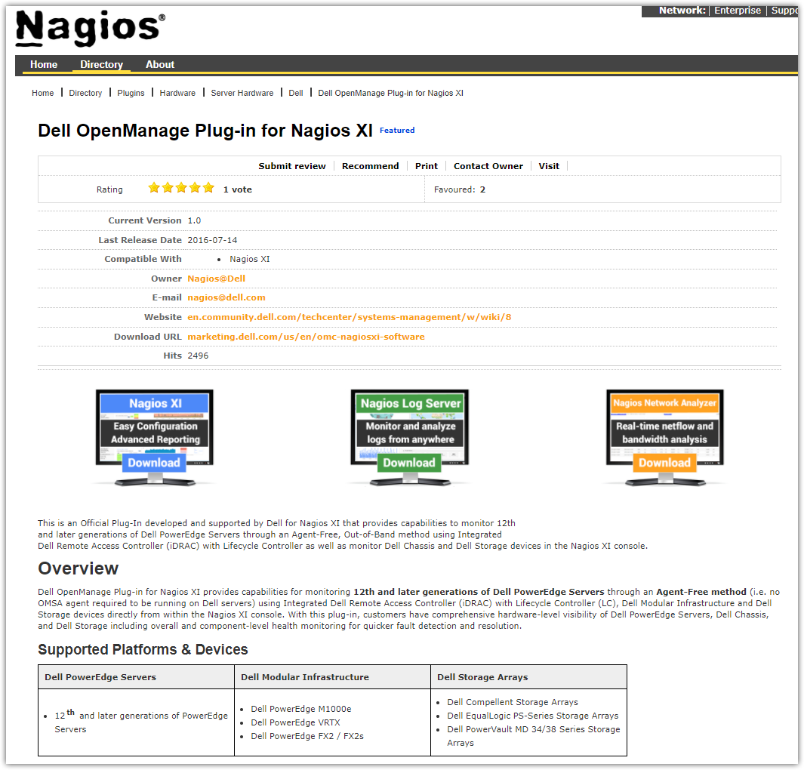
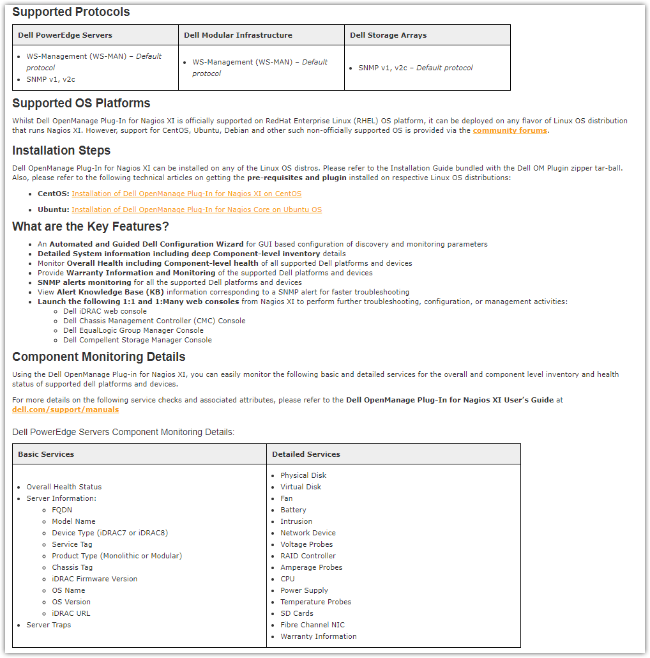
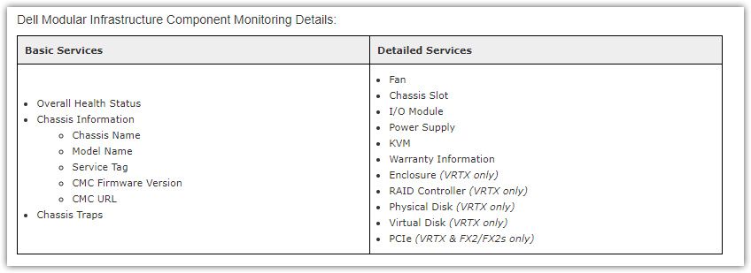
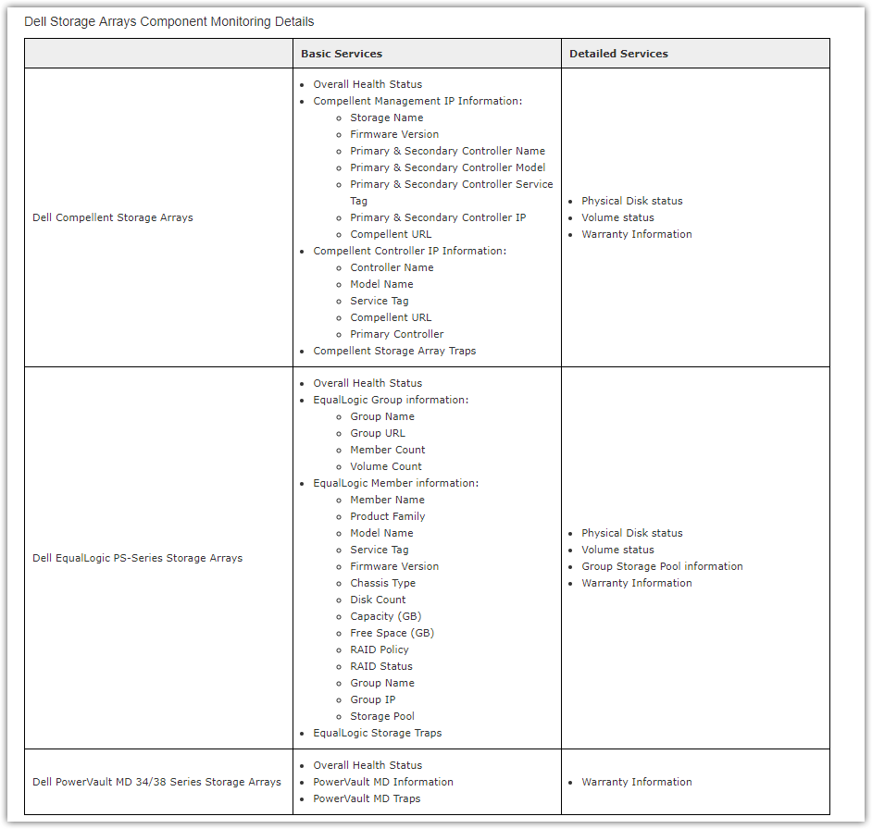
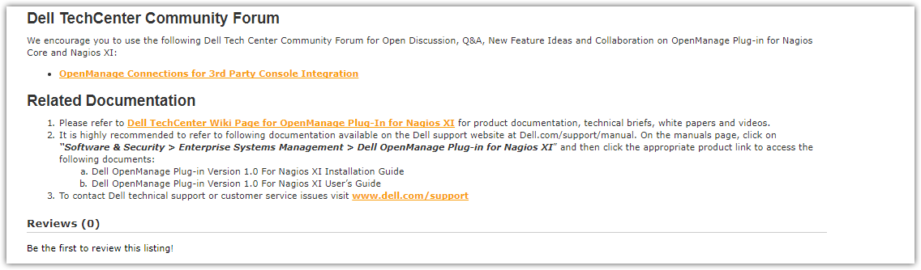

https://marketing.dell.com/us/en/omc-nagiosxi-software
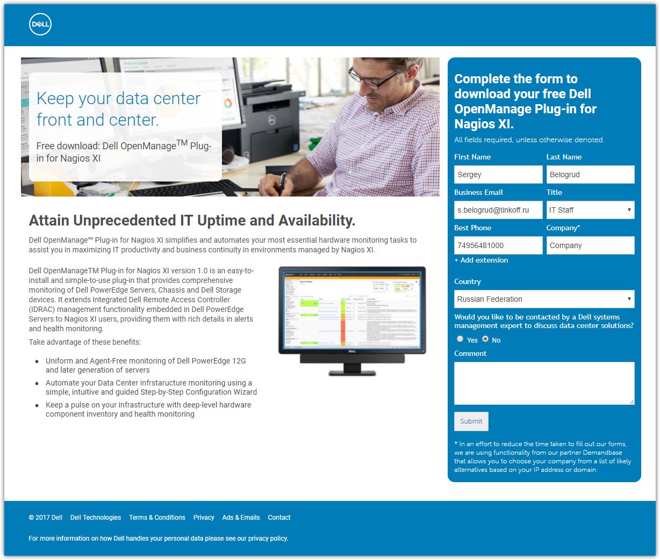

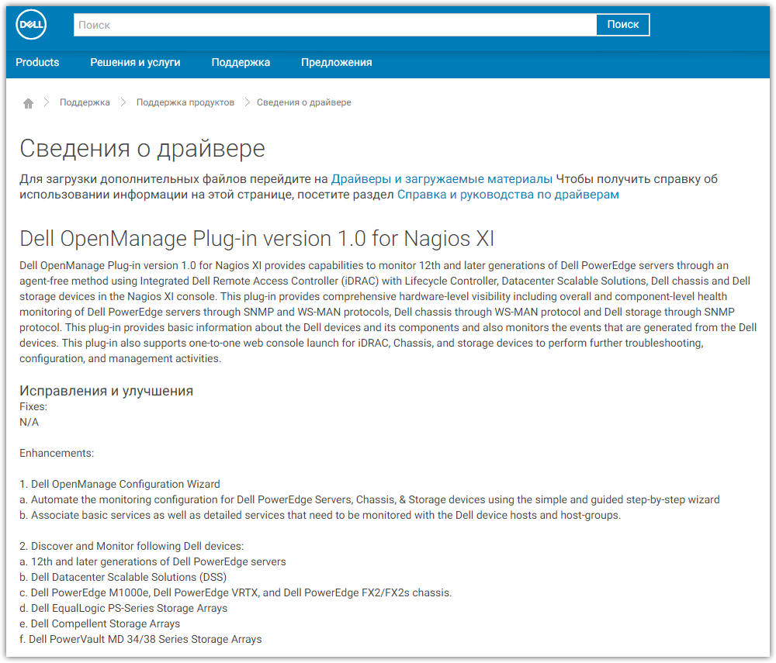
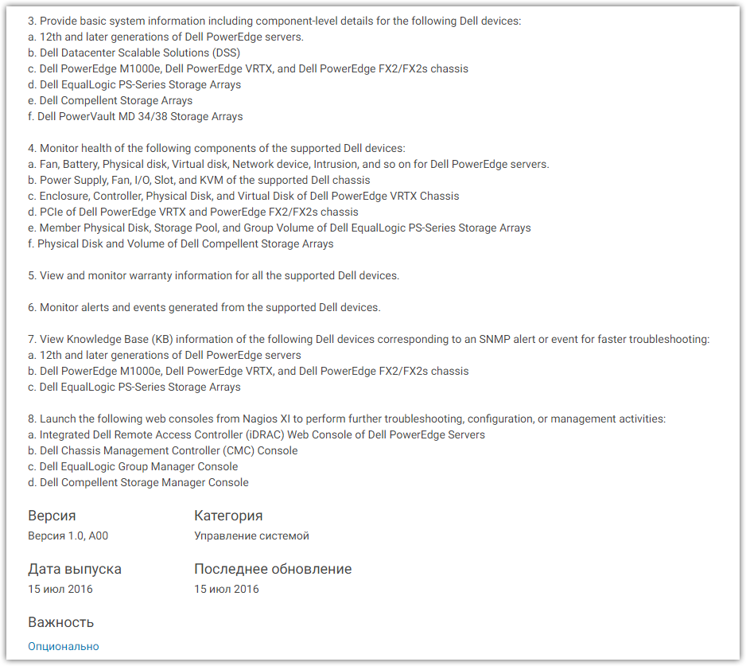
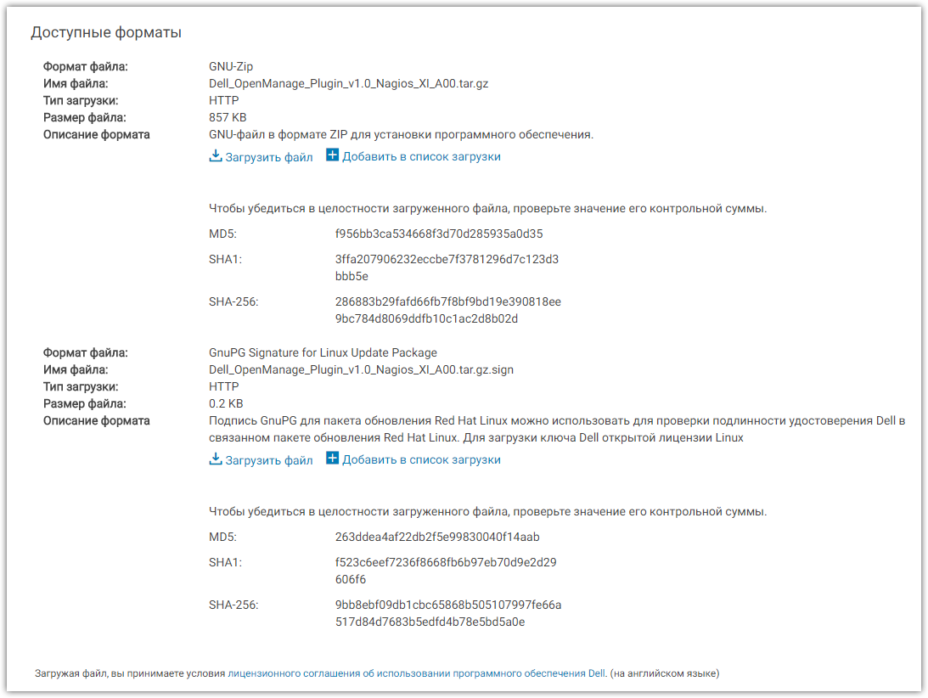
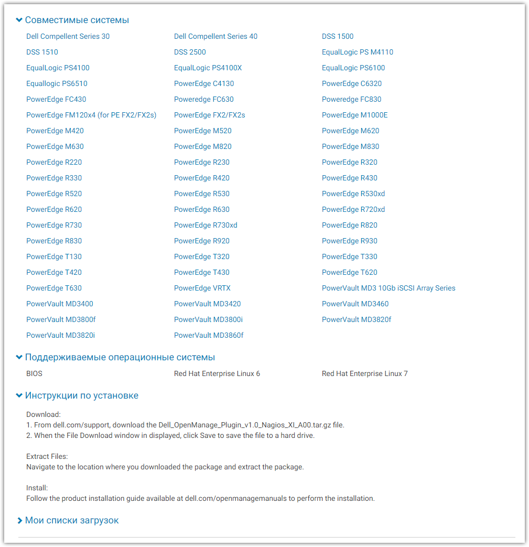

https://marketing.dell.com/us/en/omc-nagiosxi-software/thank-youus-8182BF-25736BP.html?lwp=c%3dru%26l%3dru%26cs%3drudhs1%26s%3ddhs&c=ru&l=ru&s=dhs
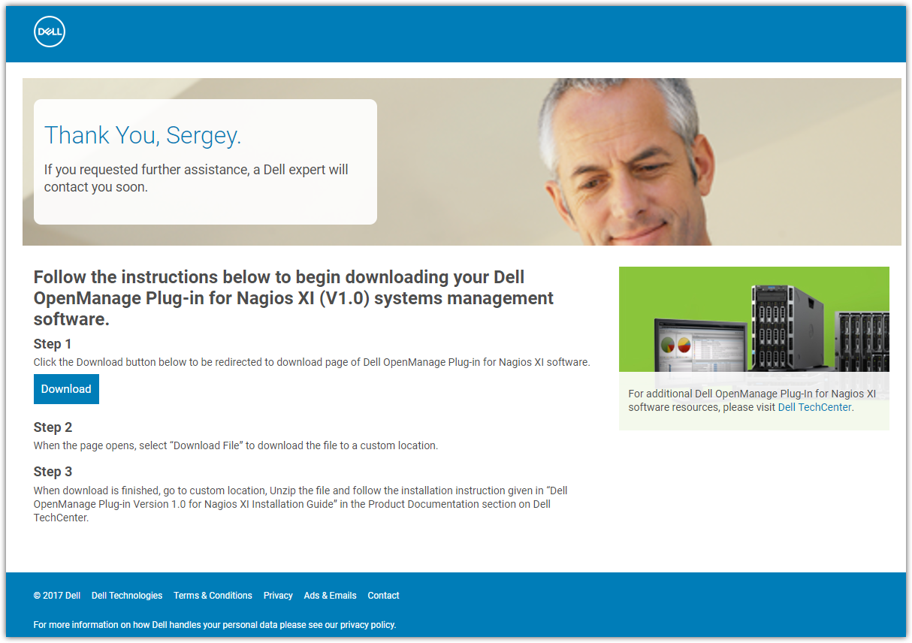

http://en.community.dell.com/techcenter/systems-management/w/wiki/12187.installation-of-dell-openmanage-plugin-for-nagios-xi-on-centos
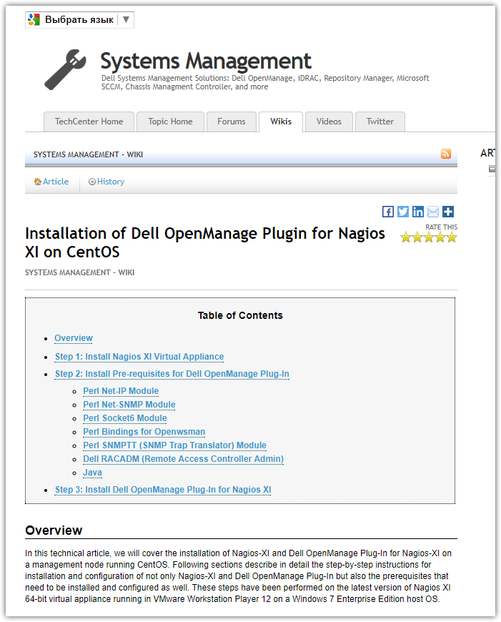
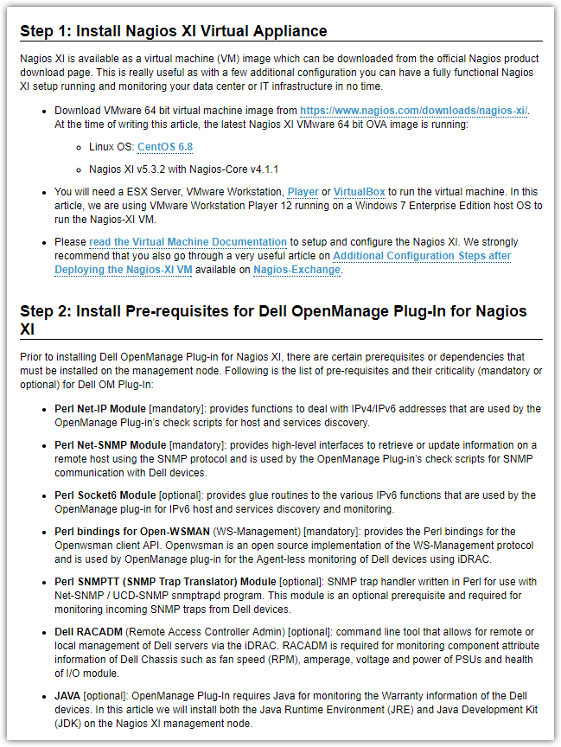
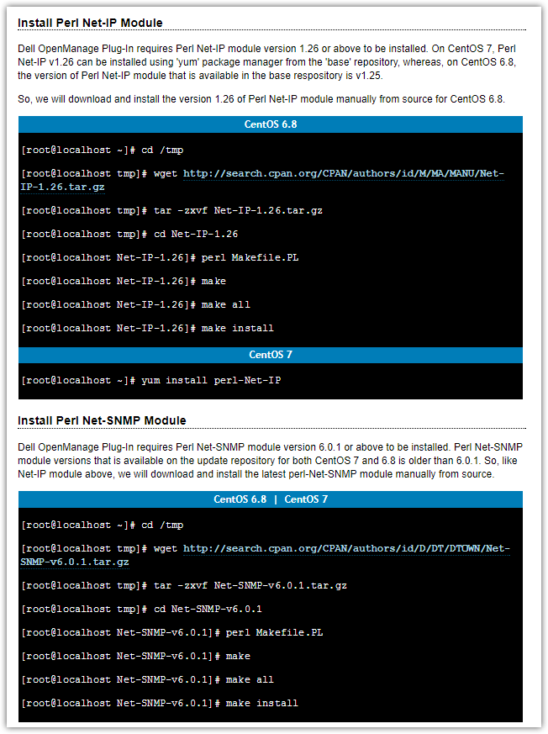
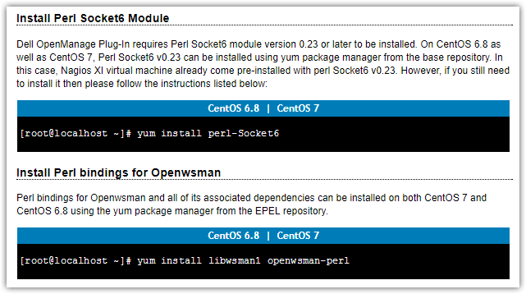
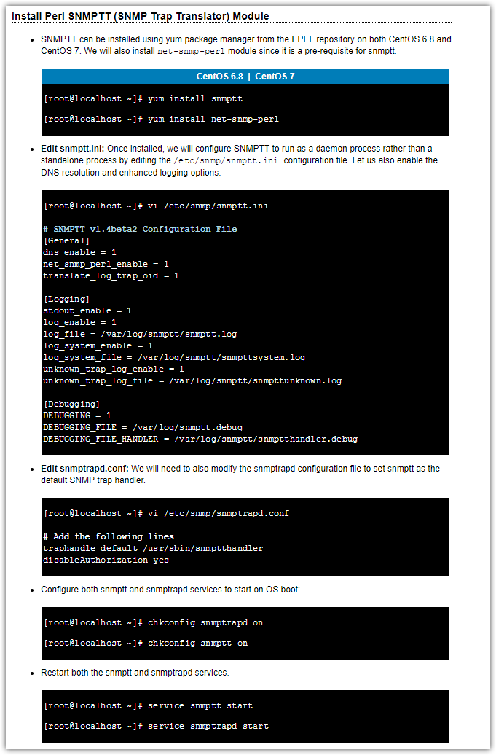
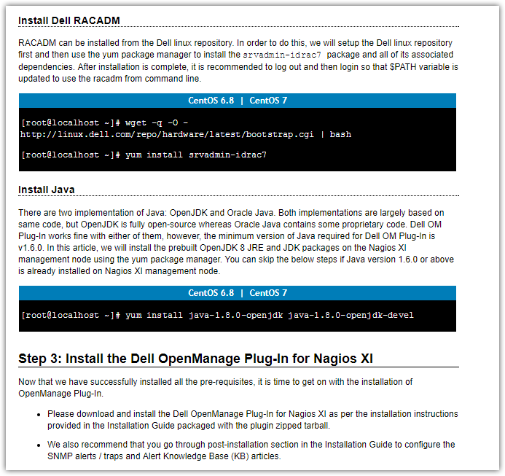

[root@vm-vol-nag4-tst ~]# yum search libwsman1 openwsman-perl perl-Socket6 perl-Net-IP
Loaded plugins: etckeeper, product-id, security, subscription-manager
This system is not registered to Red Hat Subscription Management. You can use subscription-manager to register.
================================================================================================== N/S Matched: libwsman1 ===================================================================================================
libwsman1.i686 : Open-source Implementation of WS-Management
libwsman1.x86_64 : Open-source Implementation of WS-Management

================================================================================================ N/S Matched: openwsman-perl ================================================================================================
openwsman-perl.x86_64 : Perl bindings for openwsman client API

================================================================================================= N/S Matched: perl-Socket6 =================================================================================================
perl-Socket6.x86_64 : IPv6 related part of the C socket.h defines and structure manipulators

================================================================================================= N/S Matched: perl-Net-IP ==================================================================================================
perl-Net-IP.noarch : Perl module for manipulation of IPv4 and IPv6 addresses
perl-Net-IP-CMatch.x86_64 : Efficiently match IP addresses against IP ranges with C
perl-Net-IP-Match-Regexp.noarch : Efficiently match IP addresses against ranges
perl-Net-IPv4Addr.noarch : Perl extension for manipulating IPv4 addresses
perl-Net-IPv6Addr.noarch : Check validity of IPv6 addresses

Name and summary matches mostly, use "search all" for everything.
[root@vm-vol-nag4-tst ~]#

